2023 1st International Symposium on Carbon Materials for Energy, Environment, Sustainability, and Bio-applications (2023 ISCM-1) with 6th Taiwan Carbon Conference
Poster Competition Guidelines
The Poster Award Competition aims to encourage researchers and students to improve and exchange their research progresses, thereby increasing knowledge and research potential in carbon materials through poster presentations. The organization will form a selection committee by inviting several reviewers. The committees will choose and recognize the best presentations.

- Registration information：
Presenters entering the poster award competition，please submit the abstract on the website of 2023 ISCM-1 (http://2023-ISCM-1.conf.tw) before the Abstract Submission Deadline( 2022/9/30)，and select the “Apply” for “Poster” during the abstract submission. The review results and confirmation of acceptance will announce on 2022/10/31.

- Grading Information:
- Poster time and location：the competition posters should be pasted at the poster location. (B1F, Wen-Hui Building, National University of Tainan) before 2pm on 2023/1/31.
- Participants must present their poster and answer questions. The following are the selection criteria:
- 30% for originality
- 30% for research content
- 30% for Q&A performance
- 10% for poster design
Committees will evaluate the score and the final list of award winners for the Poster Award Competition, including First place award, Second place award and Merit award.
- The Awards for poster competition will be announced prior to the closing ceremony of the Annual Meeting.
First place award: Certificate of achievement and NTD 2000.
Second place award: Certificate of achievement and NTD 1000.
Merit award: Certificate of achievement

- Poster information
- Poster size：A0 (84.1 cm × 118.9 cm)-Portrait Direct type
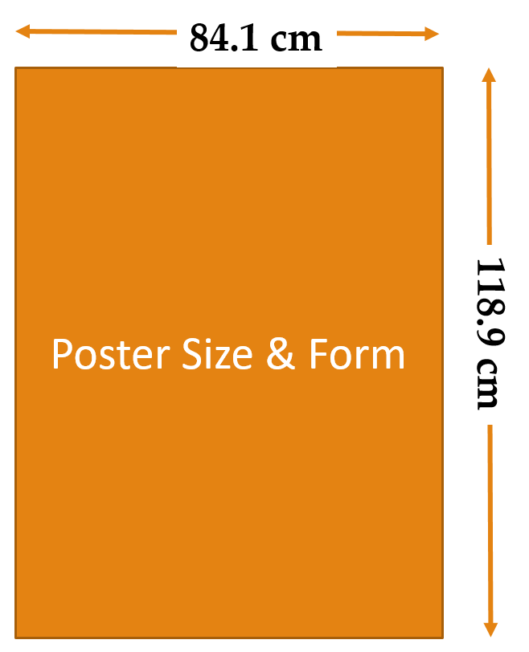
- The conference will provide the post tools.

